Section 6. Employment Situation

According to Nation Master, the total amount of people in the labour force in South Korea is 25.77 million in 2012. 7.3% of the labour force engage in agriculture, 24.3% engage in industry, and 68.4% engage in the service sector (*NationMaster.com*) (See Appendix E, Figure 1 for Distribution of Labour Graph). The minimum wage in South Korea is 5.72 USD per hour (*Trading Economics*). The minimum wage has been growing consistently (See Appendix E, Figure 2 for Yearly South Korea Minimum Hourly Wage). The minimum wage for expats differ greatly depending on occupation. HackerNest needs to hire engineers and high-tech specialists to set up and run hackathons. HackerNest should pay those employees with a yearly salary of anywhere between 30,000 USD to 62,000 USD (*Just Landed*). HackerNest should be aware of the government policy regarding minimum wage. According to the Minimum Wage Commission of Republic of Korea, all temporary, daily or part-time, and foreign employees are covered under the minimum wage. However, apprentices who have been in the apprenticeship for less than 3 months receive 10% less than the hourly rate of minimum wage, and workers who have low ability to work due to physical or mental disabilities are not covered by the minimum wage act. HackerNest should consider workers’ living costs, comparable workers’ wages, labour productivity and income distribution ratio when determining the wage rates. According to Numbeo, the cost of living index in Seoul is 85.53, which is relatively higher than the cost of living index in Toronto (See Appendix E, Figure 3 for Indices Difference between Seoul and Toronto). This implies that if an employee has 4000 USD to live in Toronto, this employee needs around 4400 USD to maintain the same standard of life in Seoul (*Numbeo*). Based on this comparison, HackerNest’s splinter cell in Seoul should offer members of the executive board with higher salaries.

HackerNest should also consider maximum work hours in terms of employment. The Koreans are known for their intelligence and work ethic. There is no wonder why the country has one of the highest average annual work hours and overtime hours in the world (*Just Landed*). HackerNest should be prepared to put in a lot of hours and effort into its ongoing projects. The Labour Standard Acts regulate the maximum weekly working hour to 40 hours. However, the acts allow the overtime working hours to be extended up to 12 hours per week. Meanwhile, a number of lawsuits lodged by labour unions claim that 52 hours should be the maximum working hour per week. Reduction of overtime hours to improve worker’s quality of life has been one of the agenda pushed by the government (*Korean Labor Law for Foreign Employers*). With the election of the new president, the labour law will be amended and more detailed restriction on overtime will be enforced. HackerNest should try not to exceed the maximum weekly working hours. If exceed, HackerNest should offer incentives to its workers to make sure they are productive. Holidays should also be considered when HackerNest decides salaries and working hours. The Ministry of Labour in Korea has implemented system in which workers who do not miss a day of work in one week receive one paid holiday. Employees who do not miss a day of work in a full year are entitled to a 15-day paid vacation and an additional day for each two years of service. For workers who miss days of work, they should expect a reduction in paid leave time. After the first year of work with a company, every two subsequent years translates into another paid holiday. HackerNest should expect its employees taking paid vacations during any time of the year. National holidays are celebrated by the majority of the Korean population. Thus, HackerNest should give workers time off on national holidays. These holidays include New Year’s Day, Lunar New Year’s Day, Independence Movement Day, Labour Day, Buddha’s Birthday, Memorial Day, Liberation Day, Harvest Moon Festival (Chuesok), Foundation Day, Hangul Day, and Christmas Day. However, it is the employee’s choice of whether to receive salary on these holidays (*Just Landed*).

South Korea has strict labour laws. Labour Standard Act sets the standards for the conditions of labour in conformity with the constitution, thereby securing and improving the living standards of workers. Act on the Protection of Dispatched Worker establishes standards for working conditions (*Ministry of Employment and Labor*). The Child Labor Law prohibits the employment of persons under 15 without a special employment certificate from the Labor Ministry. To obtain employment, children under 18 must obtain a written approval from either parents or guardians. If HackerNest will hire minors, HackerNest should only require minors to work only a limited number of overtime hours and prohibit from employing them at night. Further beyond, workers in South Korea are obligatory to subscribe to Industrial Accident Insurance against work-related accident, disease or death, the Health Insurance, the Employment insurance, the retirement pension, and the national pension plans. As regards the payment of insurance premiums, employers and the Korean government bear part of the fees. People pay insurance fees based on their income (*Ministry of Employment and Labor*). The Korea Occupational Safety and Health Agency (KOSHA) is responsible to regulate the workplace safety of small and medium-sized enterprises. Through the publication of Occupational Safety and Health Act, KOSHA emphasizes on businesses’ responsibility of following the act to prevent industrial accidents and create a comfortable working environment. To avoid violation, HackerNest needs to establish a management system for occupational safety and health, prepare preventative measures for harmful and dangerous equipment, facilities and materials, and periodically provide employees with necessary safety and health education (Jung).

South Korea’s strong and efficient labor force is set upon the foundation of the nation’s education. Korean’s parents’ fervor regarding their children’s education has resulted in the production of a large number of well-educated people. The basic school system is composed of kindergarten, elementary school, middle school, high school, and university. Since 2004, all South Koreans are required to finish middle school under compulsory education. There are thousands of post-secondary institutions in South Korea. By 2014, there are 166 special schools, 139 junior colleges, 201 universities, and 1209 graduate schools (See Appendix E, Figure 4 for Number of School in South Korea in 2014). Korea’s post-secondary institutions produce talented young people specializing in science, engineering, business, and so on. Many of those educated adults understand English. A large number of talented people also engage in cutting-edge research. A vast range of projects are undertaken from basic research to the development of advanced technologies and innovative new commercial products. HackerNest will benefit from the talented individuals in South Korea. Individuals with an engineering or technology major can be hired as hackathon organizers or mentors. Job seekers with a business degree can be hired as accountants, consultants, managers, and secretaries. To reach out to more people and spread hackathon, HackerNest can consider accepting university-student volunteers to help organize tech socials and hackathons.

On a side note, the Koreans value gender equality. In 1987, the government passed the Equal Employment Act to prevent discriminatory practices against female workers in regard to hiring and promotion opportunities. In 2001, South Korea became the first country to launch a Ministry of Gender Equality. The ministry set up 20 specific tasks to be achieved in six areas—to revise and establish laws that involve discrimination in any sector and to increase the representation of women, to facilitate women’s employment, to increase educational opportunities for women, to provide social welfare policies for women, to promote women’s involvement in social activities, and to strength the cooperation of Korean women’s organizations with international women’s organizations. Today, Korean women are engaged in a wide variety of fields, including education, medicine, engineering, the arts, law, literature, and sports (*Ministry of Employment and Labor*). The recent updates on labor laws have improved conditions for women to take time off to look after young children. To be more specific, a maternity leave allows a mother or her spouse to take off up to one year to look after an infant, and the time off must be included in the total service period of the employee (*Ministry of Employment and Labor*). Witnessing women making significant contributions to the Korean society, HackerNest should offer equal opportunities for both men and women. Furthermore, discriminate against a recipient of “childcare leave” should never be allowed.

In conclusion, to open up a subsidy in Seoul successfully, it is imperative for HackerNest to follow the labor acts set by the government, pay workers with reasonable wages, regulate workspace conditions, respect women, and value talented individuals.

Appendix E.

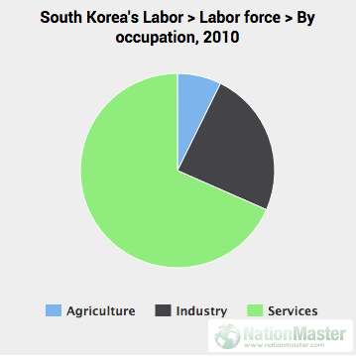

Figure 1.

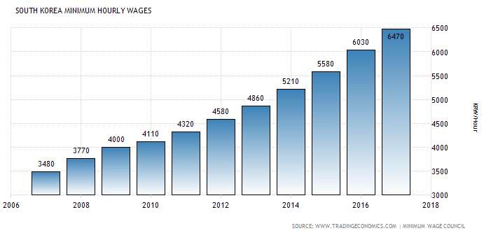

Figure 2.

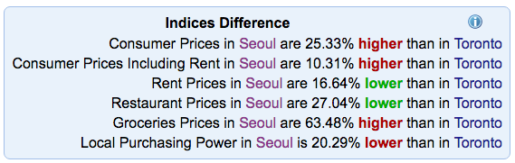

Figure 3.

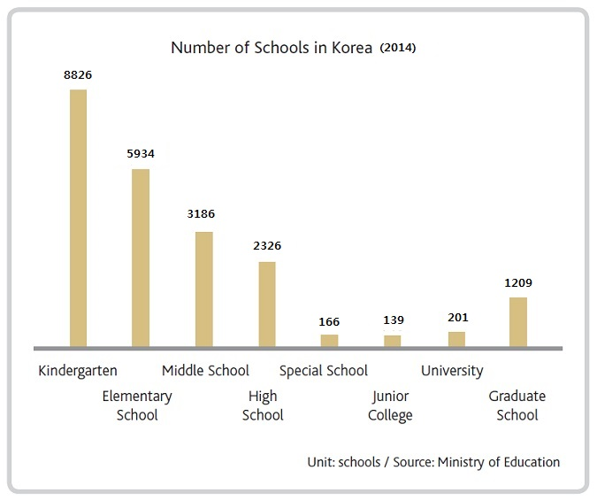

Figure 4.

<http://www.nationmaster.com/country-info/profiles/South-Korea/Labor>

<https://www.justlanded.com/english/South-Korea/South-Korea-Guide/Jobs/Working-in-South-Korea>

<http://www.tradingeconomics.com/south-korea/minimum-wages>

<http://www.minimumwage.go.kr/eng/sub04.html>

<https://www.numbeo.com/cost-of-living/compare_cities.jsp?country1=Canada&country2=South+Korea&city1=Toronto&city2=Seoul&tracking=getDispatchComparison>

<http://www.koreanlaborlaw.com/what-is-the-maximum-overtime-hours-allowed-in-korea/>

<https://www.justlanded.com/english/South-Korea/South-Korea-Guide/Jobs/Labor-regulations-social-security>

Ministry of Employment and Labor

<http://www.ilo.org/safework/areasofwork/lang--en/index.htm>

<https://www.linkedin.com/pulse/occupational-safety-health-act-employer-duties-korean-labor-attorney>